Validation of Discrete Element Models Developed in Abaqus to Simulate Rigid Body Motions
Ketan R Gupta¹; Saurabh Shiradhonkar² (2025)
¹ Former M.Tech. Student, Dept. of Earthquake Engineering, Indian Institute of Technology Roorkee, Haridwar 247667, India.
² Assistant Professor, Dept. of Earthquake Engineering, Indian Institute of Technology Roorkee, Haridwar 247667, India.

1 Simulation of static response of a single rectangular rigid block
A rectangular rigid block subjected to static base acceleration can undergo sliding, or rocking, or slide-rocking modes. Shenton III (1996) derived mathematical criteria for these rigid body deformation modes of a rectangular rigid body of width 2B and height 2H. The deformation mode was expressed as a function of aspect ratio (B/H), coefficient of static friction between the rigid block and ground (µ), and base acceleration (A_{g}). Figure 1 shows the criteria for deformation modes of a rigid block of aspect ratio 0.5 for range of static friction coefficients(µ), when subjected to static ground acceleration (A_{g}).
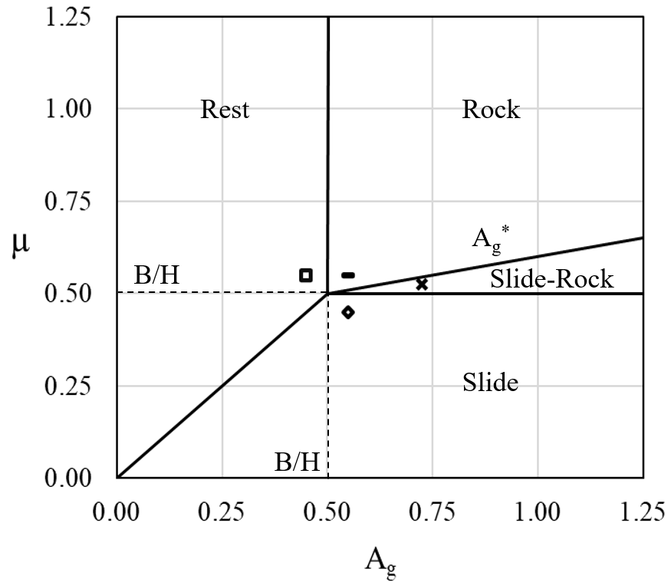 | 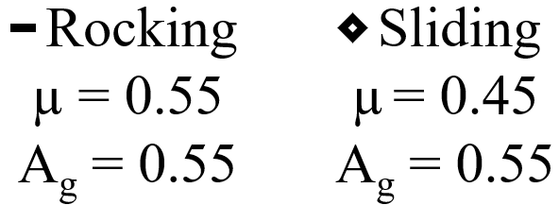  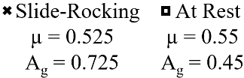
Figure 1 Criteria for initiation of different rigid body motions (Shenton III, 1996)
For validation of DEM, a rectangular rigid block of base dimension 200 mm x 200 mm and height 400 mm, and a square rigid base of dimension 300 mm x 300 mm and thickness 20 mm were modeled as two discrete elements. The square base was restrained in the vertical (Z) and horizontal directions (X and Y). The coefficient of friction between the rectangular block and square base was varied between 0.45 to 0.55, and the rigid block was subjected to different static accelerations (A_{g}) in the X direction to produce rocking, sliding, slide-rocking, and at-rest motions. The pair values of friction coefficient and static base acceleration were selected from the criteria for different rigid body modes. Figure 1 shows criteria for different rigid body modes. The rigid body modes of a rectangular rigid block for a pair of A_{g} and µ are shown in Figure 2. It can be seen that the rigid body motions exhibited by rigid block in DEM are consistent with the analytical criteria. Thus, the implemented DEM scheme accurately reproduced the motion of single rigid block under static load conditions.
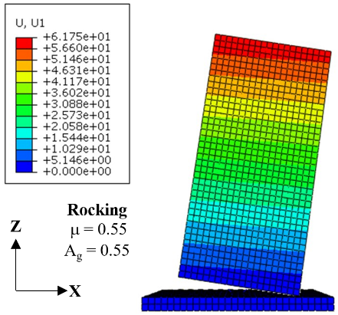 | 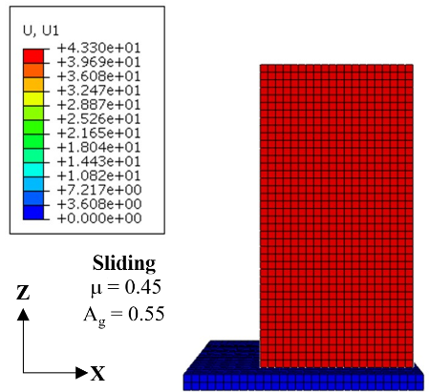
a. Rocking | b. Sliding
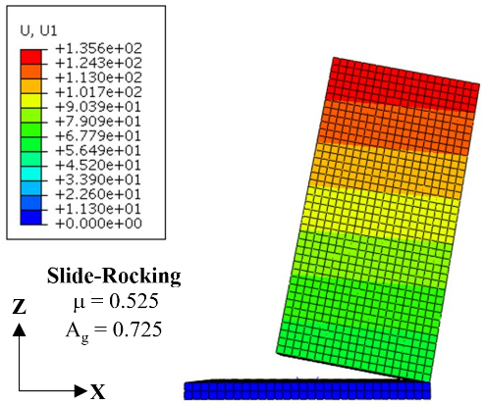 | 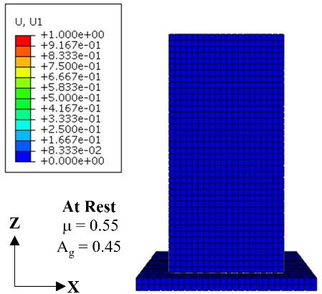
c. Slide Rocking | d. at Rest
Figure 2 Deformation modes of Rigid block simulated using DEM

2 Simulation of dynamic rocking response of a single rectangular rigid body
Housner (1963) derived an analytical expression for the decaying oscillatory amplitude of a rigid block set into rocking motion on a rigid base. The decay of oscillatory amplitude in every half cycle is caused by loss of kinetic energy due to impact. A rectangular rigid block and a square rigid platform (mentioned in section 1) were modeled as two discrete elements in Abaqus. A large value of friction coefficient was considered between rectangular block and platform to prevent sliding motion. The rectangular block was subjected to an initial rotation of 20 degrees and allowed to rock freely under its self-weight. Figure 3 compares the response of the rigid block from DEM with analytical study (Housner, 1963). A good match is observed between simulated response in DEM and response from analytical study.
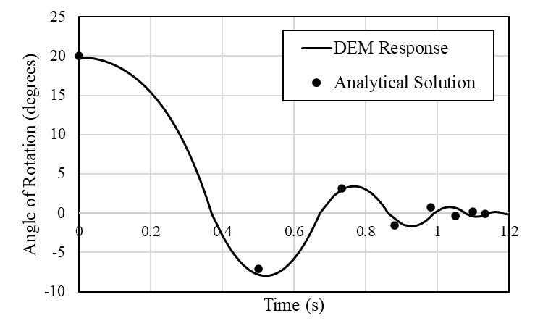
Figure 3 Comparison of rocking response of a rigid block simulated in DEM with response from analytical formulation

3. Simulation of dynamic rocking and sliding responses of multiple rigid bodies
3.1 Free sliding oscillations of multiple rigid block
Ning and Zhao (2013) developed the analytical formulation for the dynamic sliding response of three stacked rigid wedges over an inclined plane. The details of the wedges considered in the study are shown in Figure 4a. To ensure simultaneous sliding of all three wedge, friction coefficient at the sliding planes 1, 2, and 3 were taken 0.55, 0.58, and 0.60, respectively. The assembly was subjected to sinusoidal horizontal and vertical base motions of amplitudes 1.0 g and 0.5 g, respectively. The frequency of both the base motions was 1 radian/sec. The assembly of rigid wedges 1, 2, and 3 was modelled in DEM, and sliding responses of the wedges were obtained under similar base motion. Figure 4b compares sliding responses of three wedges from DEM with the those obtained from analytical solution. A reasonable agreement is observed between the DEM simulation and the analytical solution for sliding response.

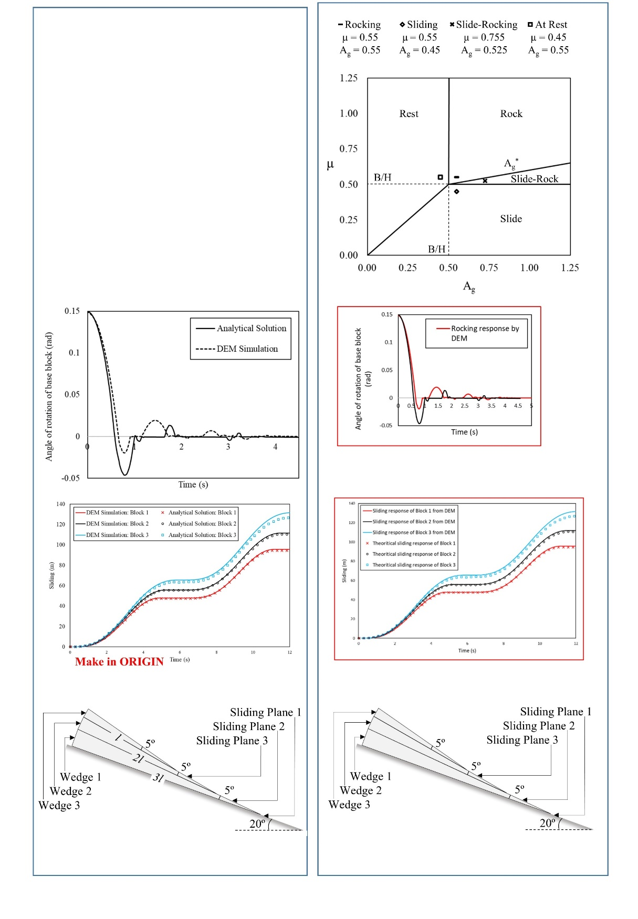 | 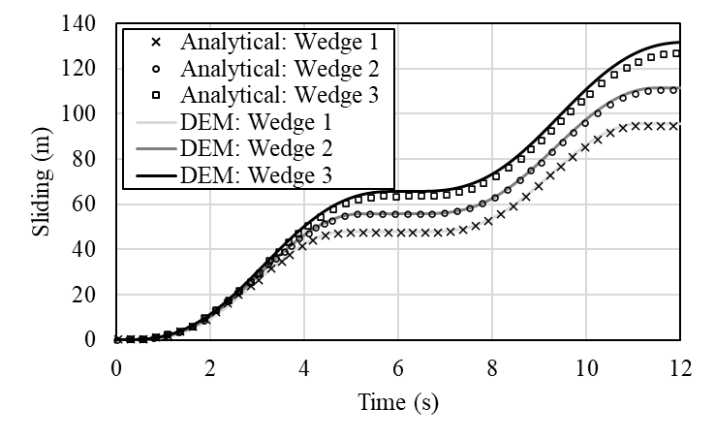
- Assembly of three rigid wedges placed on an inclined surface | - Comparison of sliding response of wedges from DEM with analytical formulations
Figure 4: Simulation of sliding response of a stack of three rigid blocks under sinusoidal base excitation
3.2 Free rocking oscillation of multiple rigid blocks
Spanos et al. (2001) derived analytical solution for oscillatory rocking response of a stack of two rigid blocks. It was assumed that some portion of the top block is always in contact with the bottom block and some portion of the bottom block is always in contact with the base. This assumption negates the possibility of bouncing of blocks during oscillations. Spanos et al. (2001) illustrated the response of a stack of two rigid blocks released to rock freely from initial rotation of 8.6˚. Slenderness ratios (H/B) of top and bottom block were 2.5 and 1.0, respectively. A DEM of this assembly of rigid blocks was developed and subjected to initial rotation of 8.6˚ (Figure 5a). However, no provision was made to inhibit the bouncing of blocks. This is because in DEM it is not feasible to ensure no-bouncing condition and for practical application of DEM the rigid blocks can experience bounding during dynamic response. Figure 5(b) compares oscillatory rocking response of bottom rigid block with the analytical prediction. The response from DEM matches well with analytical response in the first quarter cycle of oscillation i.e. rotation of bottom block from initial position to vertical position. However, the responses vary substantially in the second and third quarter cycle. This is due to disengagement (bouncing) of the top rigid block over the bottom rigid block due to impact of bottom block with the base (Figure 5c).
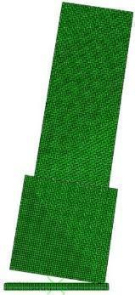 | 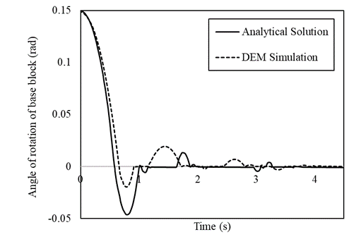
- Stack of two rigid blocks subjected to Initial condition | - Rocking oscillation of bottom block from DEM and analytical formulation (Spanos et al. 2001)
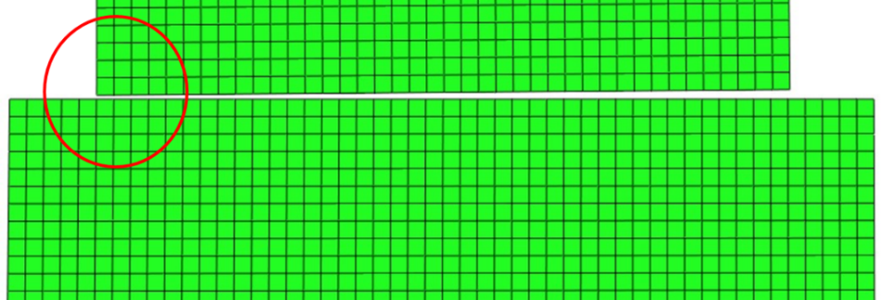
- Bouncing of top rigid block due to impact of bottom block with foundation
Figure 5. Simulation of free oscillatory rocking of stack of two rigid blocks in DEM
Thus, the DEM framework accurately reproduced rocking, sliding, and sliding rocking modes of single and stack of multiple rigid blocks. The validated DEM framework was used for modeling of dry jointed voussoir arch bridge

